Sri Lanka Institute of Information Technology



# Lab Submission <Lab sheet No-08>

**<IT23782372>**

**<Mendis M.M.N>**

**Probability and Statistics| IT2120**

B.Sc. (Hons) in Information Technology

1. Calculate the population mean and population standard deviation of the laptop bag weights

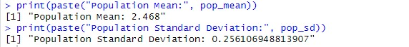

1. Draw 25 random samples of size 6 (with replacement) and calculate the sample mean and sample standard deviation for each sample.

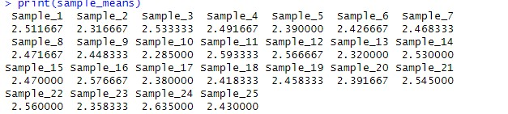

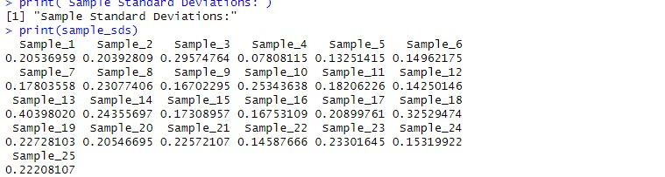

|  |
| --- |
|  |

1. Calculate the mean and standard deviation of the 25

sample means and state the relationship of them with true mean and true standard deviation.

